Name : K.AravindRoyal

Trainer Name:- Harshee pithoda

Course Name:-python for machine learning

Date:-02/06/2022

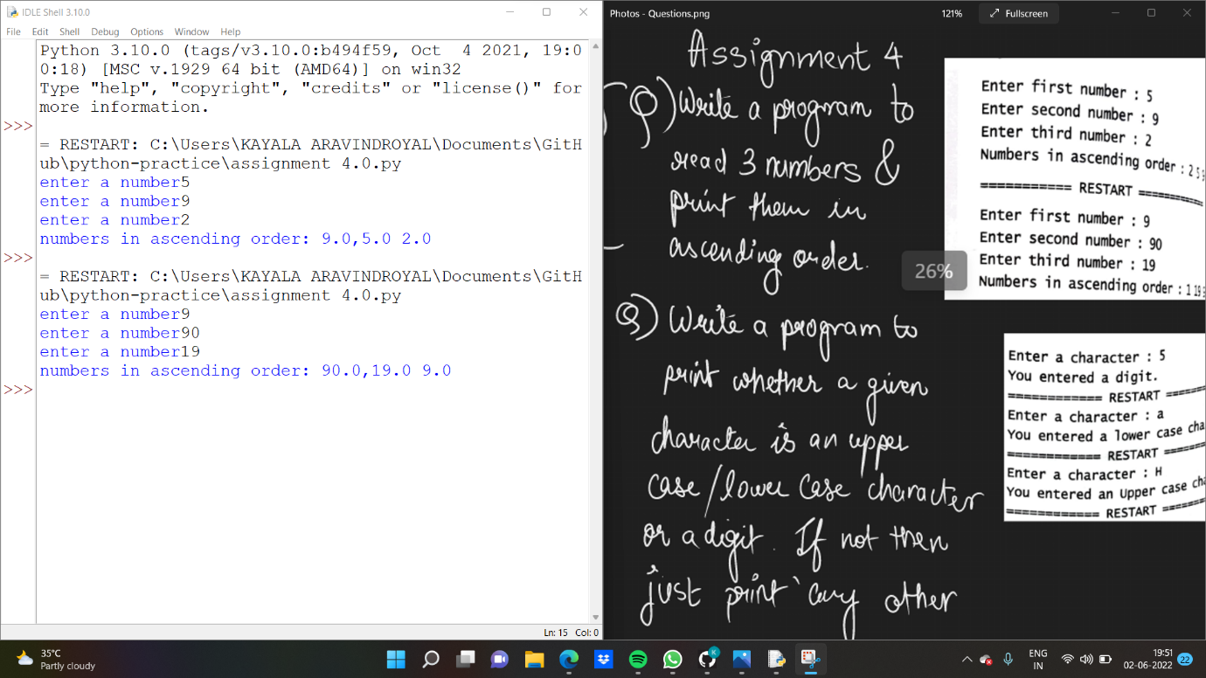

a=float(input('enter a number'))

b=float(input('enter a number'))

c=float(input('enter a number'))

if a>b and a>c:

print('numbers in ascending order:',a,end=',')

if b>c:

print(b,c)

else:

print(c,b)

elif b>a and b>c:

print('numbers in ascending order:',b,end=',')

if a>c:

print(a,c)

else:

print(c,a)

elif c>a and c>b:

print('numbers in ascending order:',c,end=',')

if a>b:

print(a,b)

else:

print(b,a)

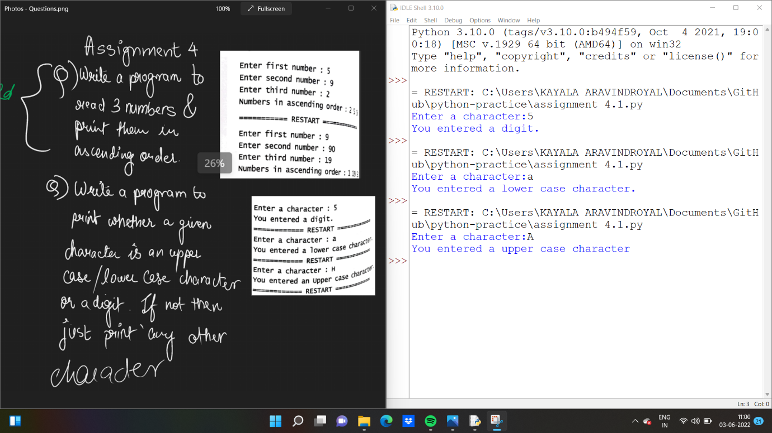

a=str(input('Enter a character:'))

if a.isdigit():

print('You entered a digit.')

elif a.islower():

print('You entered a lower case character.')

elif a.isupper():

print('You entered a upper case character')

else :

print('carry other character')